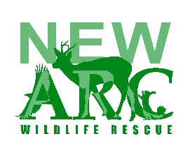 |  | Volunteer Application Form
About you
Name |  |  |  |  |  |  | Preferred Pronoun |  |  |  |  |  | Date of Birth
Address |  |  |  |  |  |  |  |  |  | Landline
 |  |  |  |  |  |  |  |  |  | Mobile
 |  |  |  |  |  |  |  |  |  | Email
Emergency contacts
Full Name |  |  |  | Relationship |  |  |  |  |  |  |  | Number
Do you have any conditions that may affect your volunteering which we need to be aware of?
e.g. allergies, illness, autism, learning difficulties, diabetes
Yes/No | If yes, please provide details
Do you have any phobias? (e.g. birds or worms)?
Yes/No | If yes, please provide details
What areas would you like to volunteer for? Feel free to tick more than one box!
Animal care at the centre |  |  |  |  |  | Animal transport
Maintenance i.e. gardening, woodwork
Please indicate which day(s) and times you could be available (e.g a normal shift is 9am to 1pm)
Monday |  | Tuesday |  |  |  | Wednesday |  |  | Thursday | Friday |  |  |  | Saturday |  |  | Sunday
Why do you want to volunteer for The New Arc? Do you have any experience of working with animals?
What skills do you have that would benefit The New Arc?
Do you have any unspent criminal convictions?
Yes/No |  |  | If yes, please provide details in an email to contact@thenewarc.org

As a volunteer you agree to
- Ensure your tetanus vaccination is up to date.
- Ensure that your physical and mental health is such that you can safely carry out volunteer duties (please consult with your GP if you are unsure)
- Follow the procedures outlined in your training to ensure the welfare of animals in our care
- Follow health and safety instructions when working at the hospital
- Volunteer for a regular 3-4 hour shift at the centre
Volunteer’s signature:

